Nama : Muhammad Hanif Aji Wiratama

NIM : 18090065

Kelas : 5B

**PRAKTIKUM 1**

1. Source Code

Kenalan.php -> application/controller

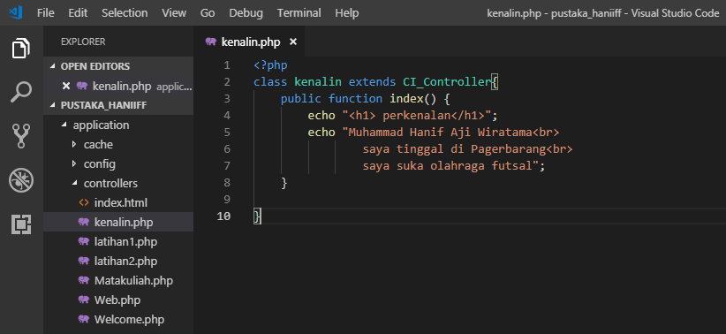

1. URL

<http://localhost/pustaka_haniff/index.php/kenalin>

1. Capture Hasil

